First Aid Box and Injuries Vocabulary

What is a first aid kit?
It is a kit that consist of a set of bandages and medicines for giving first aid to someone with an injury.
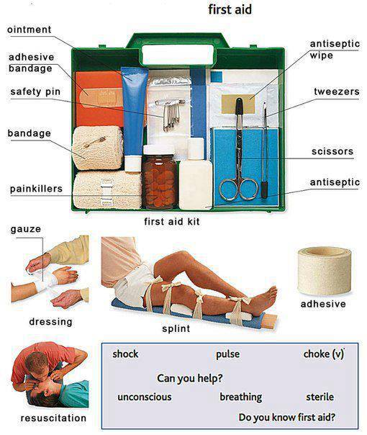

Vocabulary used in the picture
painkillers, ointment, safety pin, adhesive bandage, antiseptic, antiseptic wipe, tweezers, scissors, bandage, splint, dressing, resuscitation, gauze

