Plain Yogurt Fruit Yogurt

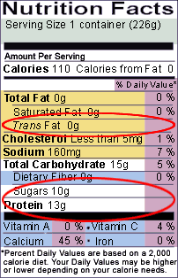 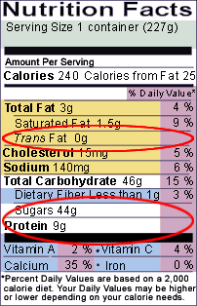

Reduced fat Milk 2% Nonfat Milk 0%

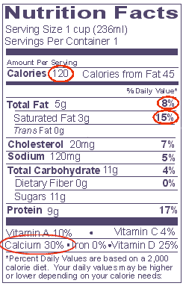 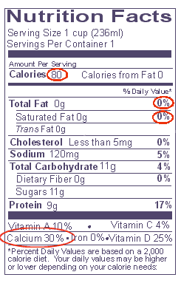[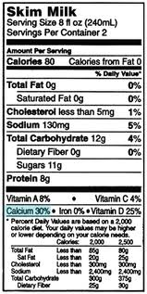](http://www.google.com/imgres?imgurl=http://4.bp.blogspot.com/_q0AmDQEBvpc/S_6WqV4WOcI/AAAAAAAAGxA/1IcuI3RchXw/s400/label-skimmilk.gif&imgrefurl=http://hiphopblog.com/folder123/99/whole-milk-label&usg=__o5XXCqYPuHmwmeEwvGzsV37Gdvc=&h=397&w=200&sz=30&hl=en&start=2&zoom=1&tbnid=SWKPzd7A_CPlTM:&tbnh=124&tbnw=62&ei=8WDDTaGPIITCvgOn6MWTAQ&prev=/search?q=milk+nonfat+nutrition+label&hl=en&biw=1020&bih=568&gbv=2&tbm=isch&itbs=1)