Objective 48
Please answer the questions about the email message.
- Who is the sender?

- Who is the email to?

- What is the email address of the sender?

- What is the subject?

- Is the subject important or not important?

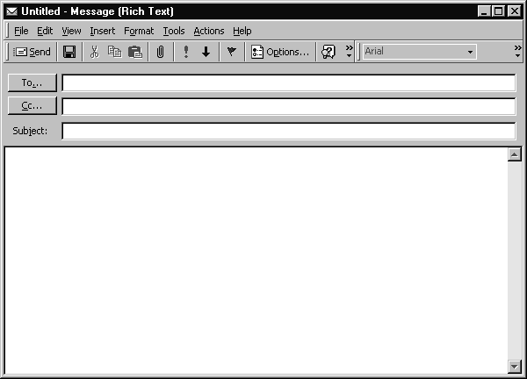
Hello Tom,
You need to be at work at 8:00 every day.
Thank you,
Gloria Anderson
Office Manager
925-555-1234
GloriaAnderson@yahoo.com

Be on time!
TomSmith@gmail.com
Message

