Always wash your hands and wear gloves.
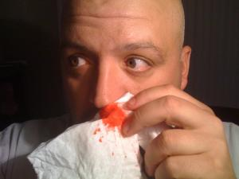 | 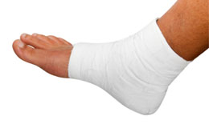 |  | 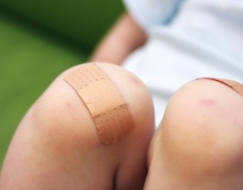 | 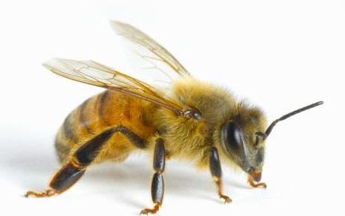
Bloody Nose  What to do:  - Sit down.  - Lean forward.  - Pinch the nose for 10 minutes.  Call the doctor after 20 minutes of bleeding. | Sprain  What to do:  - Rest.  - Ice for swelling.  - Compress with bandage.  - Elevate.  - Call the doctor right away. | Minor Burn  What to do:  - Put the burn under cool water for 10 minutes.  - Put on a clean bandage.  - Go to the hospital for major burn. | Minor Cut or Scrape  What to do:  - Put a sterile bandage on the cut or scrape.  - Press to stop bleeding.  - Wash with soap and water.  - Put antibiotic ointment.  - Put on a clean bandage.  - Go to the doctor for a major cut or scrape. | Bee Sting  What to do:  - Call 9-1-1 for an allergic reaction.  - Remove the stinger.  - Ice the area.  - Keep it clean.

