Mi Pueblo

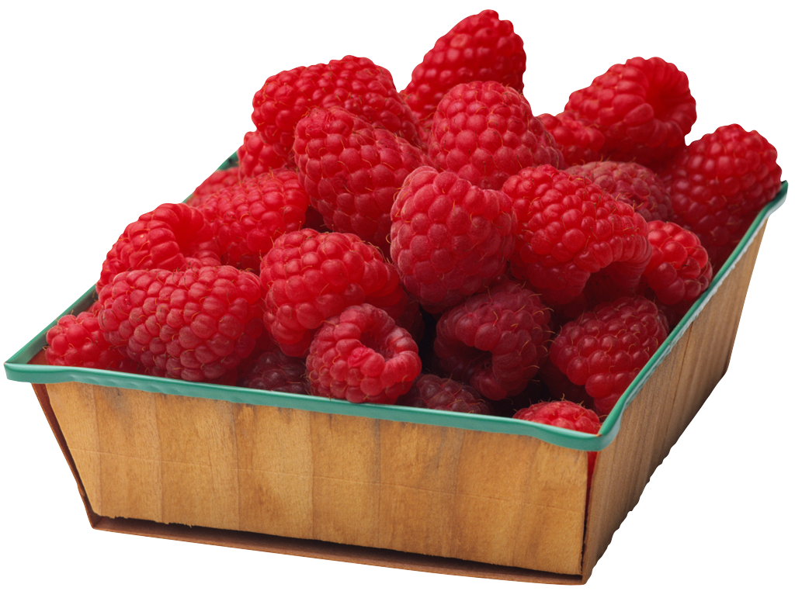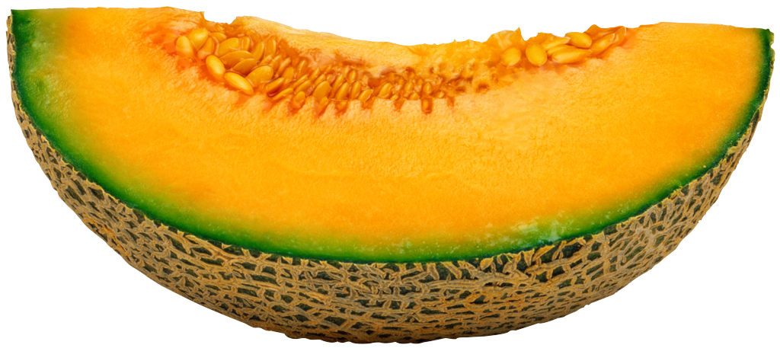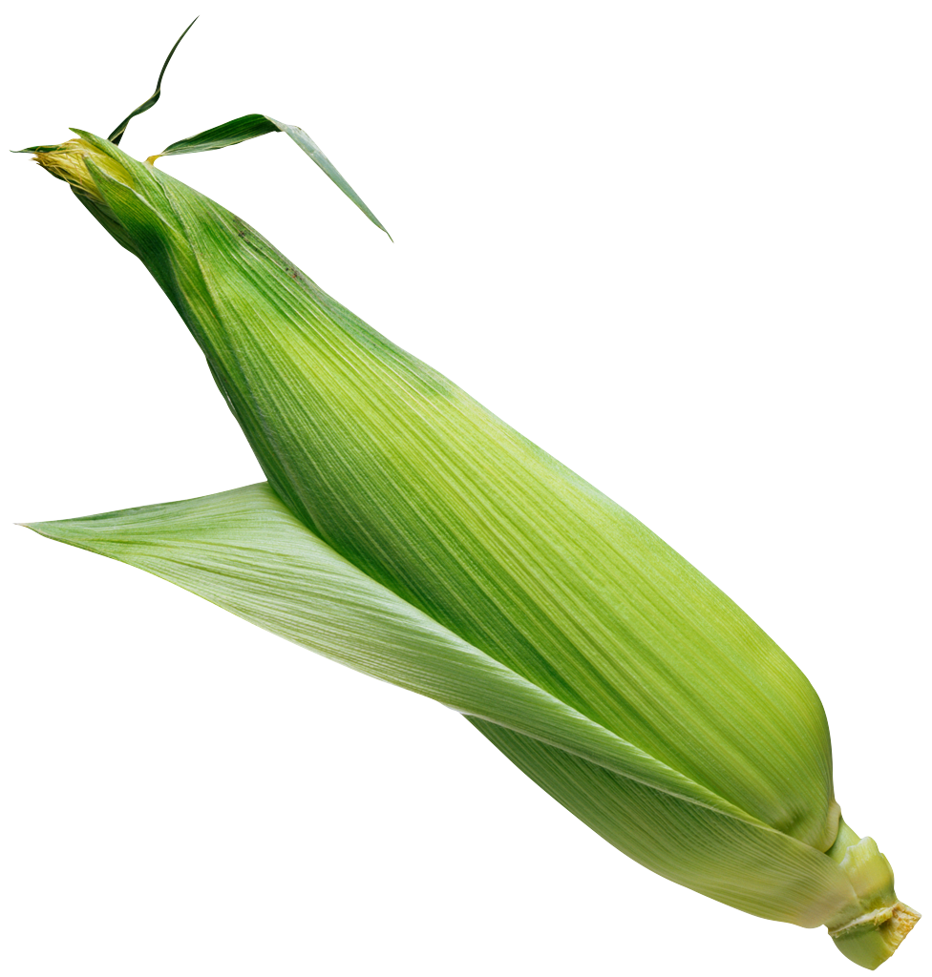

CORN 25¢ Each MELON $1.99/lb. RASPBERRIES $3.00/basket

FoodMart

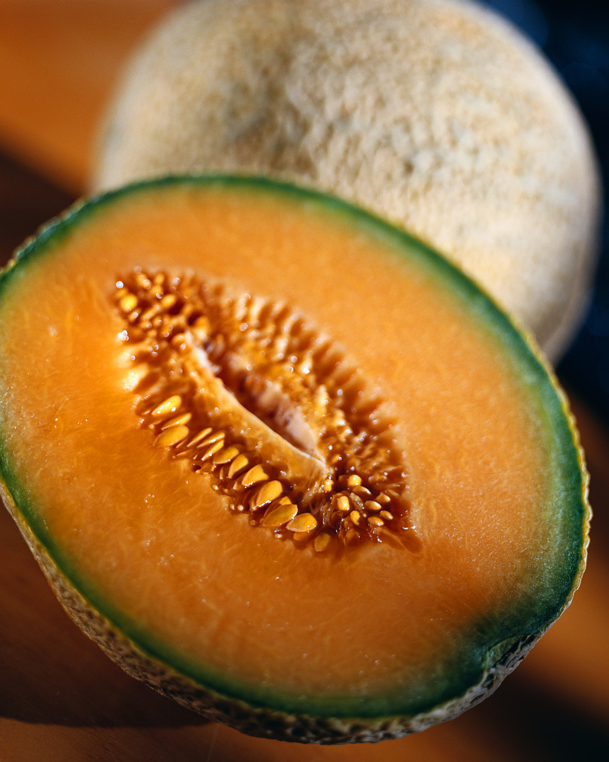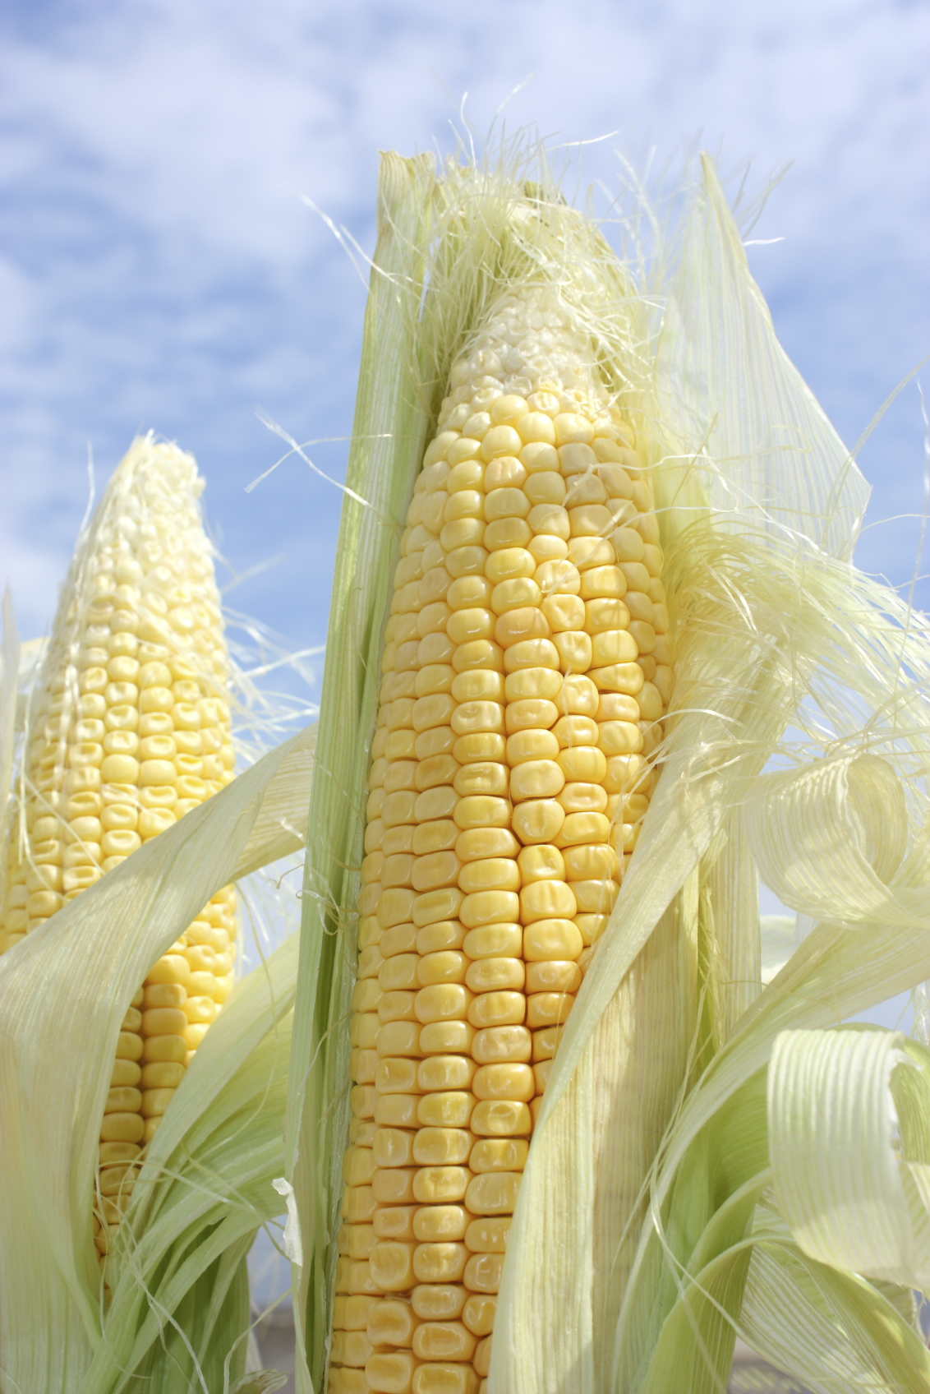

MELON $1.79/lb. RASPBERRIES $2.89/basket CORN 20¢ Each

Best Farms

Macintosh HD:Users:jamesfitzsimmons:Downloads:MC900215366.WMF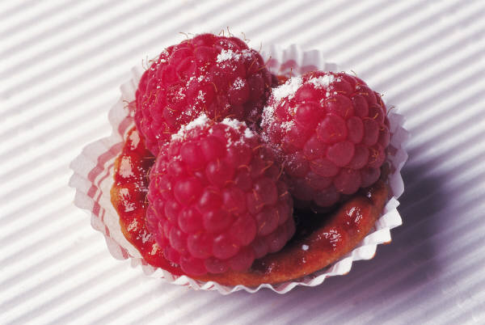

RASPBERRIES $2.99/basket CORN 23¢Each MELON $1.89/lb.

Choose two (2) produce items and write in the chart.

Write the price for each item under the name of the store.

ITEMS MiPueblo FoodMart Best Farms

1. ___________ __________ __________ __________

2. ___________ __________ __________ __________

What store has the best prices? ________________________________

Las Montanas Market

Macintosh HD:Users:jamesfitzsimmons:Downloads:MC900246133.WMF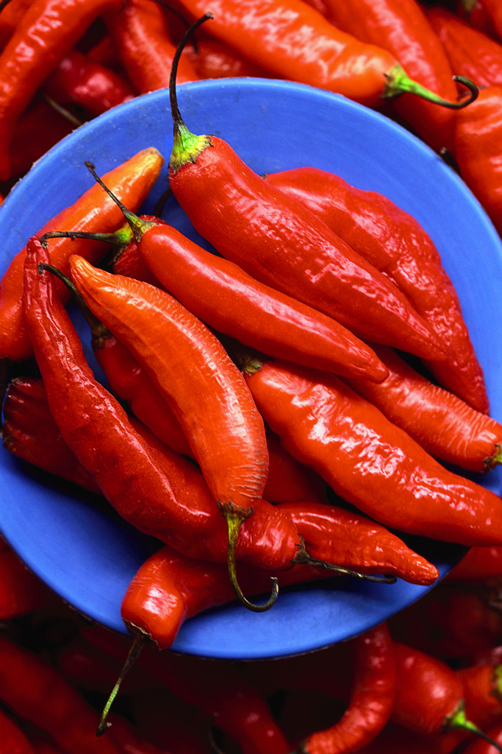Macintosh HD:Users:jamesfitzsimmons:Downloads:MC900232573.WMF

ARTICHOKE RED CHILIS $$0.79/lb. PUMPKIN $3.99 Each

$ 1.50 Each

__________________________________________________________________________

Lucky Stores

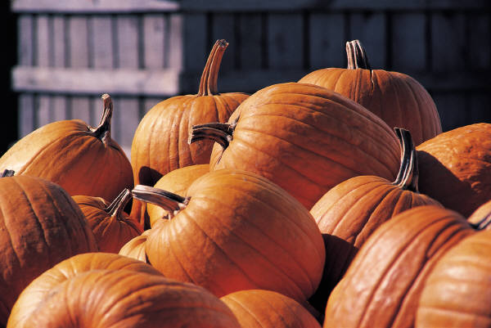Macintosh HD:Users:jamesfitzsimmons:Downloads:MC900016737.WMF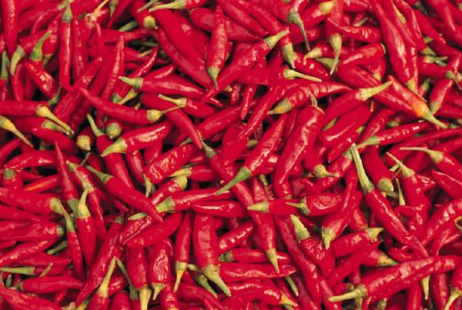

RED CHILIS $0.99/lb. PUMPKIN $4.39 Each ARTICHOKE$1.75Each

__________________________________________________________________________

Vons Market

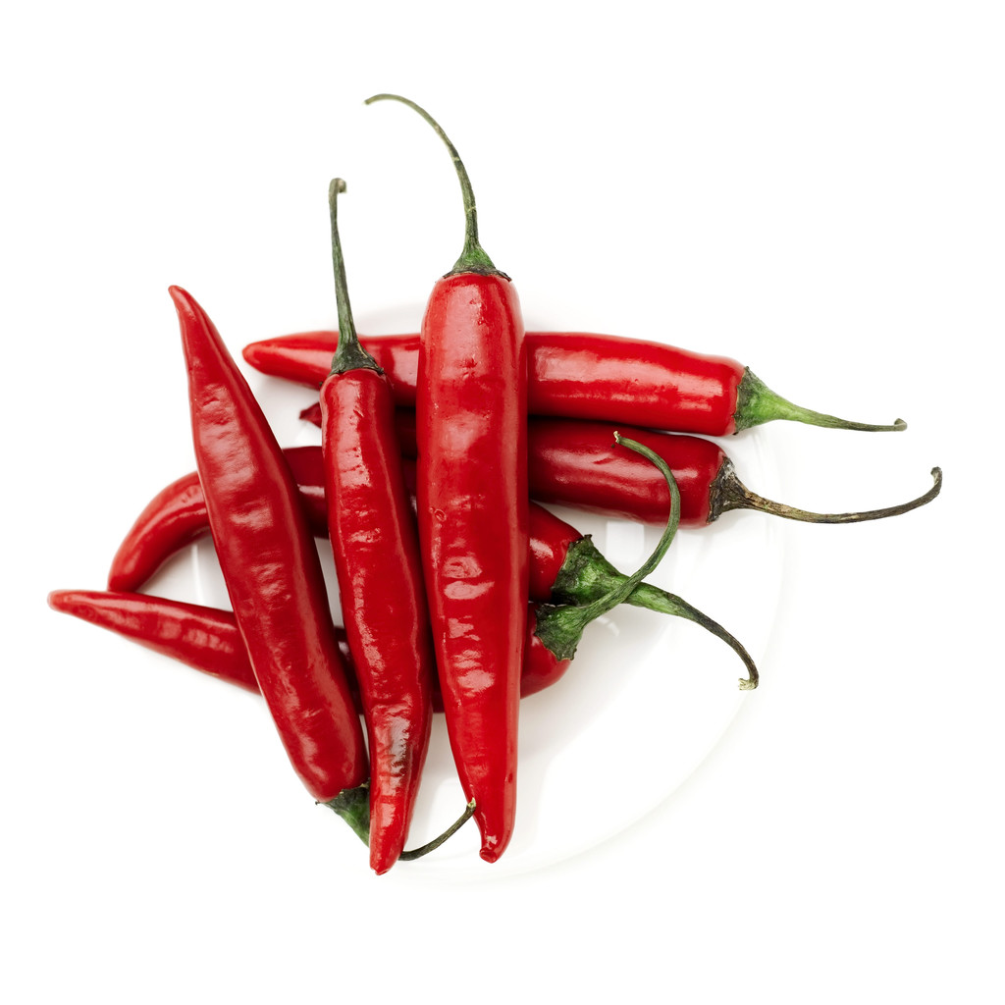Macintosh HD:Users:jamesfitzsimmons:Downloads:MC900296200.WMF

Macintosh HD:Users:jamesfitzsimmons:Downloads:MC900215506.WMF

PUMPKIN $2.99 Each ARTICHOKE $1.99Each RED CHILIS $1.09/lb.

Choose two (2) produce items and write in the chart.

Write the price for each item under the name of the store.

ITEMS Las Montanas Lucky Stores Vons Market

1. ___________ __________ __________ __________

2. ___________ __________ __________ __________

What store has the best prices? ________________________________

Las Montanas Market

Macintosh HD:Users:jamesfitzsimmons:Downloads:MC900232707.WMFMacintosh HD:Users:jamesfitzsimmons:Downloads:MC900215159.WMF

CUCUMBER BLUEBERRIES PAPAYAS$1.99 Each

$ 0.79/lb $3.50/basket

__________________________________________________________________________

Lucky Stores

Macintosh HD:Users:jamesfitzsimmons:Downloads:MC900331285.WMFMacintosh HD:Users:jamesfitzsimmons:Downloads:MC900331259.WMF

Macintosh HD:Users:jamesfitzsimmons:Downloads:MC900331244.WMF

BLUEBERRIES PAPAYAS $1.79 Each CUCUMBER$0.59 /lb

$2.99/basket

Vons Market

Macintosh HD:Users:jamesfitzsimmons:Downloads:MC900246139.WMF

Macintosh HD:Users:jamesfitzsimmons:Downloads:MC900332210.WMFMacintosh HD:Users:jamesfitzsimmons:Downloads:MC900264526.WMF

PAPAYAS $2.00 Each CUCUMBER $0.99/lb BLUEBERRIES

$3.29/basket

**COMPARE THE PRICES**

Choose the three (3) produce items and write in the chart.

Write the price for each item under the name of the store.

PRODUCE

ITEMS Las Montanas Lucky Stores Vons Market What is the best What store has the price for this item? best price for this item?

1. ___________ __________ __________ __________ ________ ____________

2. ___________ __________ __________ __________ ________ ____________

3. ___________ __________ __________ __________ ________ ____________

What store has the best prices? ________________________________