Child is safe

[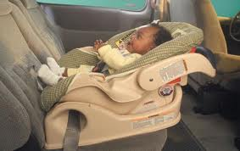](http://www.google.com/imgres?q=baby%20safe&start=102&safe=active&sa=X&biw=1024&bih=599&tbm=isch&tbnid=c3XbUFTWQcK8MM%3A&imgrefurl=https%3A%2F%2Fwww.tmcaz.com%2FTucsonMedicalCenter%2FMaternity%2FCar_Seat_Program&docid=ohe0cEIneCYtZM&imgurl=https%3A%2F%2Fwww.tmcaz.com%2Ffiles%2Fhow-to-make-a-baby-car-seat-cover.jpg&w=520&h=328&ei=oNchU-XlHY3YoATrm4G4DA&zoom=1&ved=0CCEQhBwwCDhk&iact=rc&dur=536&page=7&ndsp=15) 

 



Child is healthy







Child has family time

[](http://www.google.com/imgres?q=good%20parenting&safe=active&sa=X&rls=com.microsoft:en-us:IE-SearchBox&rlz=1I7NDKB_enUS554&biw=1008&bih=530&tbm=isch&tbnid=TdXNSyBvkjIzwM:&imgrefurl=http://www.medicinenet.com/parenting_principles_pictures_slideshow/article.htm&docid=advZrREK_WVdGM&imgurl=http://images.medicinenet.com/images/SlideShow/parenting_principles_s1_family_having_fun.jpg&w=493&h=335&ei=1p3yUszyOszxoATEuoCABw&zoom=1&iact=rc&dur=593&page=2&start=10&ndsp=15&ved=0CHsQrQMwDQ)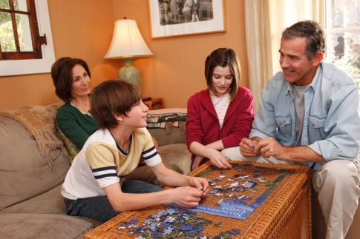

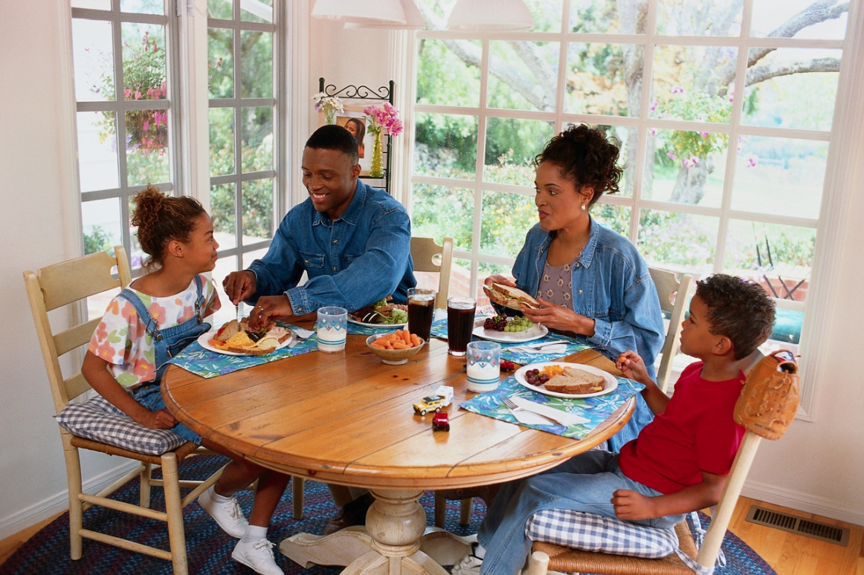

Child learns

[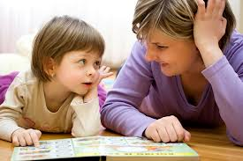](http://www.google.com/imgres?q=good%20parenting&safe=active&sa=X&rls=com.microsoft:en-us:IE-SearchBox&rlz=1I7NDKB_enUS554&biw=1008&bih=530&tbm=isch&tbnid=PMWknEQ4RXGYEM:&imgrefurl=http://www.allfamilysites.com/news/facts-about-good-parenting/&docid=Tthji8iDFqTydM&imgurl=http://www.allfamilysites.com/news/gallery/facts-about-good-parenting/facts_about_good_parenting.jpg&w=940&h=626&ei=1p3yUszyOszxoATEuoCABw&zoom=1&iact=rc&dur=515&page=2&start=10&ndsp=15&ved=0CHIQrQMwCg) [](http://www.google.com/imgres?q=good%20parenting&safe=active&sa=X&rls=com.microsoft:en-us:IE-SearchBox&rlz=1I7NDKB_enUS554&biw=1008&bih=530&tbm=isch&tbnid=Q5daFZXvSW7EAM:&imgrefurl=http://www.ziadrazak.com/page/2/&docid=fEt0LAgjIeogrM&imgurl=http://www.ziadrazak.com/wp-content/uploads/2013/09/reading.png&w=640&h=426&ei=1p3yUszyOszxoATEuoCABw&zoom=1&iact=rc&dur=515&page=4&start=38&ndsp=15&ved=0CNMBEK0DMCg)

[](http://www.google.com/imgres?q=good%20parenting&safe=active&sa=X&rls=com.microsoft:en-us:IE-SearchBox&rlz=1I7NDKB_enUS554&biw=1008&bih=530&tbm=isch&tbnid=hkM7CwXj4aJYCM:&imgrefurl=http://www.mybabiesplanet.com/parenting/good-parenting-strategies-for-dads.html&docid=tPgPNi98DxKaoM&imgurl=http://www.mybabiesplanet.com/wp-content/uploads/2011/05/good-parenting.jpg&w=507&h=338&ei=1p3yUszyOszxoATEuoCABw&zoom=1&iact=rc&dur=592&page=6&start=66&ndsp=15&ved=0CLYCEK0DMEk) 

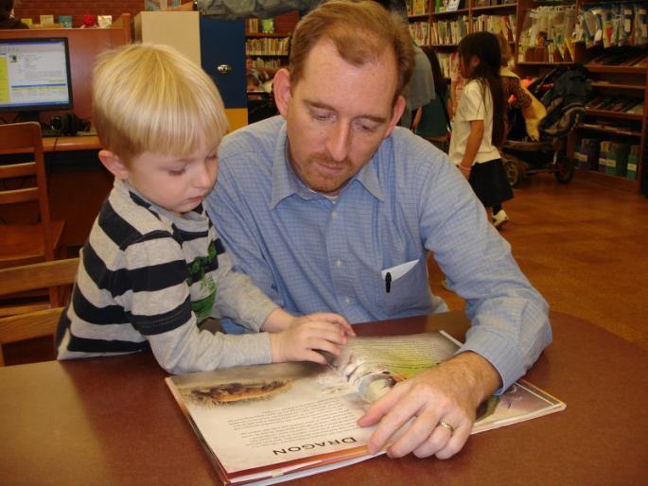

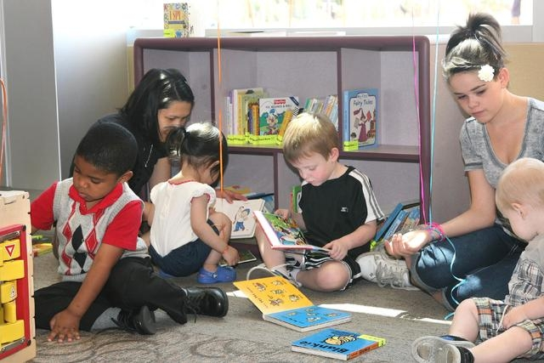

Child has more activity

[](http://www.google.com/imgres?q=good%20parenting&safe=active&sa=X&rls=com.microsoft:en-us:IE-SearchBox&rlz=1I7NDKB_enUS554&biw=1008&bih=530&tbm=isch&tbnid=pJHUR8b6C9-88M:&imgrefurl=http://www.thenewblackmagazine.com/view.aspx?index=3087&docid=3ivYyWEws2rVuM&imgurl=http://www.thenewblackmagazine.com/PhotoFiles/Good-Parenting.jpg&w=481&h=354&ei=1p3yUszyOszxoATEuoCABw&zoom=1&iact=rc&dur=546&page=3&start=25&ndsp=13&ved=0CLUBEK0DMB4)





