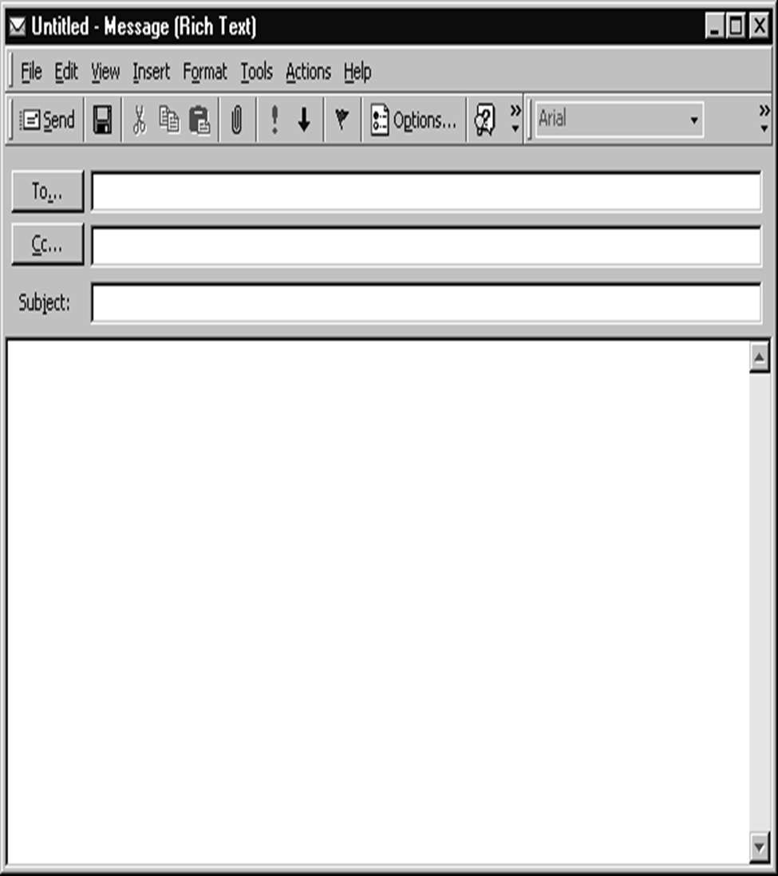

Hi Sue,

I have a doctor’s appointment tomorrow. Can you work for me from 9:00 to 12:00?

Thanks,

Mary

maryfine@email.com

Will you work for me tomorrow?

Sue Green (greens@email.com